Summary:
A highly dependable individual with a sound understanding of medical assistance and clerical tasks. Outstanding communication skills as well as great customer service skills.

Education:
Associate of Science in Medical Assisting | Baker College, Somewhere MI – 2016

Shirley Payne
Hospitalville, MI 49999
989-555-5252
spayne@yahoo.com

PATIENT CARE SKILLS:

• Vitals and blood pressure
• Injections, EKG’s and basic lab tests
• Room preparation and equipment sterilization
• Describing prescriptions
• Patients’ education and answering questions
• Coding charts Interpretation

CLERICAL SKILLS:

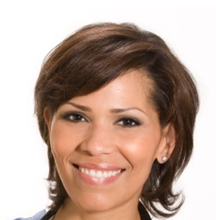
Files organization
• Collection and documentation of patient information
• Medical records maintenance
• Computer: MS Word, excel, outlook, access

Medical Assistant Intern | St. Johns Hospital, London, MI | May 2016 – Present
• Take medical histories and recording of vital signs of patients
• Prepare and manage medications, approve drug refills, telephone prescriptions to a pharmacy
• Draw blood, get patients ready for x-rays, take electrocardiograms, remove sutures, and change dressings of patients
• Explain cure procedures to patients
• Prepare patients for examinations, and support physicians for the duration of examinations
• Collect and arrange laboratory specimens and carry out basic laboratory tests
• Dispose of dirty supplies, and make medical instruments germ-free
• Educate patients about medications and special diets
• Organize examination room instruments and equipment
• Keep waiting and examining rooms tidy and clean

